

**The Ukraine-Russia War So Far: Costs, Casualties, and Equipment Losses**

Karma Thapkey, Kuenzang Tobgay, Passang Dorji, Sonam Dechen Lhaki

02220151, 02210205, 02200158, 02220169

Bachelors of Engineering in Information and Technology

College of Science and Technology

Module Code: DIS302- Data Analytics

Tutor: Mr. Yeshi Jamtsho

May , 2025

Table of Contents

Introduction 1

Research Questions 2

Data Description 2

Equipment losses 2

Russian personnel losses 3

Financial aid to Ukraine 3

Economic indicators 3

Ukraine casualties 4

Data Preprocessing 4

Equipment Losses 4

Casualties 5

Economic indicators 7

Exploratory Data Analysis 9

Russian Death Counts 9

Equipment Losses 11

Economic impacts 17

Ukraine casualties 18

Statistical Analysis and Predictive Modeling 19

Data Visualization Dashboard 24

Conclusion 30

Limitations and further work 30

References 31

Appendix 32

# Introduction

The Russia-Ukraine war that started in early 2022 continues to be one of the most significant geopolitical occurrences of the 21st century. Aside from its devastating human and economic price, the war has created a tremendous amount of data that can be broken down to understand its implications more objectively. More precisely, data on losses of war equipment, foreign aid, and civilian and military deaths offer a quantitative base upon which to estimate the magnitude and development of the war.

This mini project is designed to use data analysis to examine three most significant aspects of the war: loss of equipment, economic aid, and casualties—displaying the figures for Russia and Ukraine in contrast. By employing data from reputable open-source databases alongside government dispatches, this study hopes to expose patterns and trends depicting the ferocity of military operations, the effect of foreign aid, and the human cost of the war.

With statistical analysis and data visualization software such as Plotly, Pandas, and Dash, the project transforms raw data into meaningful charts and interactive dashboards. Not only do the analytics aim to reveal the evolving nature of the conflict but they also highlight the value of data in monitoring contemporary warfare.

The purpose of this project is to present a comprehensive, fact-oriented description of how the war affected both nations, offering informative content for purposes of aiding academic research, policy development, and public education.

# Research Questions

To guide this analysis, the following key research questions were formulated:

1. How has the level of financial and military aid to Ukraine changed over time?

2. What trends can be observed in Ukrainian and Russian personnel and equipment losses?

**3**. How has the war impacted economic indicators such as GDP

**4**. Can we detect escalation or de-escalation phases using loss and aid data?

# Data Description

## Equipment losses

The dataset on equipment losses is available in the Ukraine-Russia-War-Dataset GitHub repo and provides a cumulative daily record of military hardware losses for both Russia and Ukraine in the ongoing conflict that started on 24 February 2022. It comes to us formatted XLSX and lists nearly every kind of equipment-featuring tanks, armored personnel carriers (APCs), artillery, helicopters, aircraft, UAVs, vehicles, fuel tanks, naval ships & specialized equipment. Date-wise categorized entries allow total equipment losses to be followed chronologically. Values are cumulative counts updated daily as new data comes in from the General Staff of the Armed Forces of Ukraine. There are separate data files: one tracks losses reported to Russian forces and the other, Ukrainian losses. A third one lists equipment losses, mainly of Russian forces, that have been visually confirmed and verified by independent Oryx. These are losses that are only included if verified. Being raw data, it is cleanly structured and machine-readable but does not provide any analytical perspectives or context. It falls on the user to interpret and make sense of the data. The dataset thus allows one to compare equipment attrition of the two sides and supports various analytical approaches, including identification of trends, visualization of data, and forecasting.  
Source: -<https://github.com/leedrake5/Russia-Ukraine.git> pulled from Oryx’s site which provided up to date articles and data on ongoing wars.

## Russian personnel losses

Retrieved from the Mediazona article titled ‘*Russian losses in the war with Ukraine*’ <https://en.zona.media/article/2025/04/25/casualties_eng-trl>. Mediazona, in collaboration with BBC News Russian service and a team of volunteers, maintains a named list of deceased Russian military personnel. This list is compiled from verified, publicly available sources, including social media posts by family members, local news reports, and official announcements from regional authorities.

Source: <https://en.zona.media/article/2025/04/25/casualties_eng-trl>.

## Financial aid to Ukraine

This raw dataset captures humanitarian contributions from different countries to Ukraine as a response to this ongoing crisis, with detailed entries from March 2022 until June 2023. In every record, the fields available are: donor country, recipient country (Ukraine), the date of announcement, the sector of aid (for instance, Humanitarian assistance or Energy security), funding amount in Australian dollars (AUD), delivery channel (such, for example, United Nations agencies like WFP, UNFPA, or UNOCHA), and the purpose or description of the assistance. The data used in this project comes from the Kiel Institute for the World Economy's Ukraine Support Tracker. This dataset tracks government-to-government commitments of military, financial, and humanitarian aid to Ukraine since January 24, 2022.

Source: <https://www.ifw-kiel.de/publications/ukraine-support-tracker-data-20758/>

## Economic indicators

This data obtained for World Bank Group’s open data portal contains different economic indicators such as GDP, inflation, employment rate among others across different years. This will allow us to study the impact of the war on both countries.  
Source: <https://data.worldbank.org/country/ukraine>

## Ukraine casualties

The data for this was manually extracted from Wikipedia articled titled ‘Casualties of the Russo-Ukrainian War from the casualty section. This data contains the total confirmed losses of civilians in different provinces of Ukraine.

Source: [**https://en.wikipedia.org/wiki/Casualties_of_the_Russo-Ukrainian_War#Total_casualties**](https://en.wikipedia.org/wiki/Casualties_of_the_Russo-Ukrainian_War#Total_casualties)

**Libraries used**

* Pandas, numpy for data manipulation
* Matplotlib, seaborn for plotting
* Statsmodels and sklearn for time series and forecasting models
* Suppressed warnings using warnings.filterwarnings(‘ignore’)

# Data Preprocessing

## Equipment Losses

1. Data Loading



1. Datetime Conversion

Converted the ‘Date’ column from string format to datetime format to facilitate time-series operations



1. Setting Date as Index

Set the 'Date' column as the DataFrame index to make it time-indexed



1. Handling Missing Values

Used forward fill (ffill) to handle missing values in the dataset



1. Feature Selection

Created a subset of the data with relevant columns for analysis, such as total losses, destroyed equipment, and specific categories like tanks, aircraft, and artillery for both Russia and Ukraine

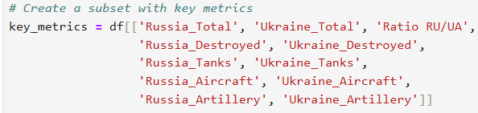

1. Missing Value Check

Verified if any missing values remained in the selected key columns

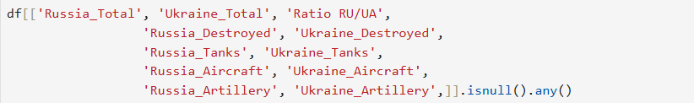

## Casualties

1. Loading Datasets

Two CSV files were loaded

* df1: Officer deaths by rank (from a GitHub source)
* df2: Weekly confirmed Russian losses



1. Manual DataFrame Creation

Since rank-based data was available in structured lists (rather than in raw CSV), a DataFrame was manually created

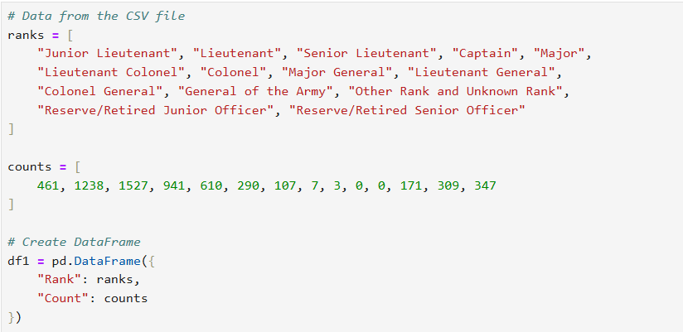

1. Sorting Values

The casualty data (df1) was sorted in descending order of deaths



**Financial aid**

1. Selecting relevant columns

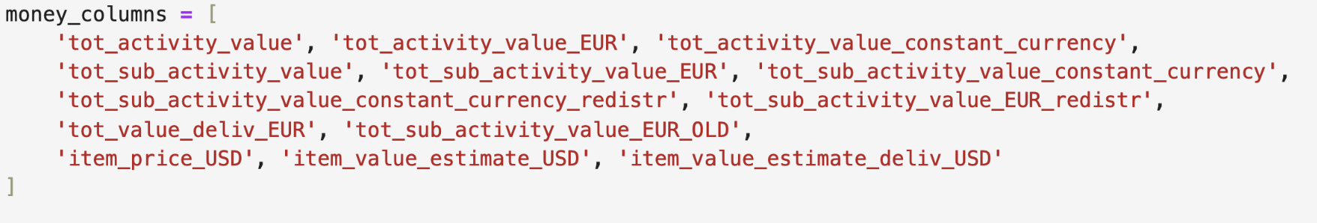

1. Change the string columns from string to numeric

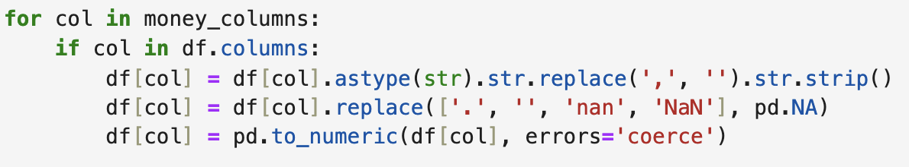

1. Converting the date of announcement to DateTime object

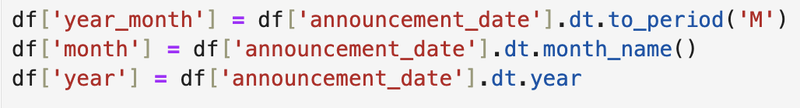

## Economic indicators

1. Selecting basic economic indicators

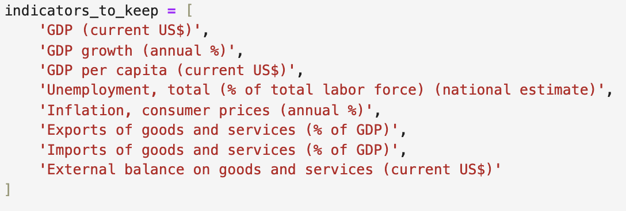

1. Setting the time range starting from 2014, the initial annexation of Crimea by Russia

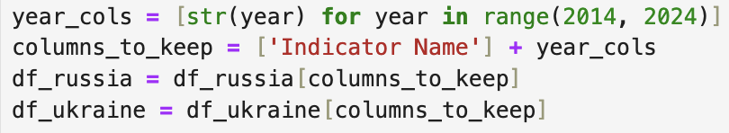

1. Changing the ‘Year’ columns into rows and the ‘Indicator Name’ into columns



1. Null values (2) were found for Russia’s inflation values for the year 2022 and 2023

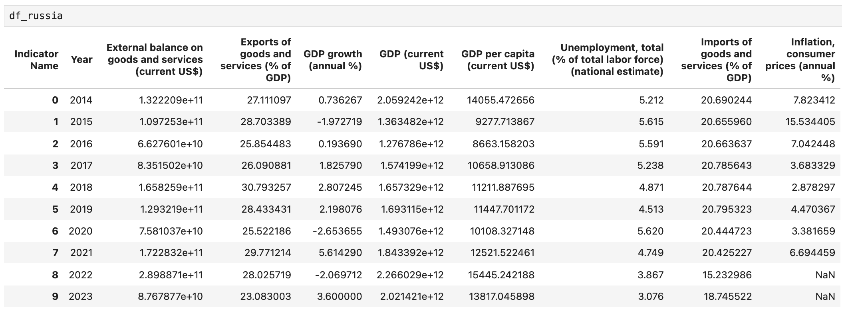

They were filled in using the Russia inflation rate values retrieved from: <https://tradingeconomics.com/russia/inflation-cpi14.3>



# Exploratory Data Analysis

## Russian Death Counts

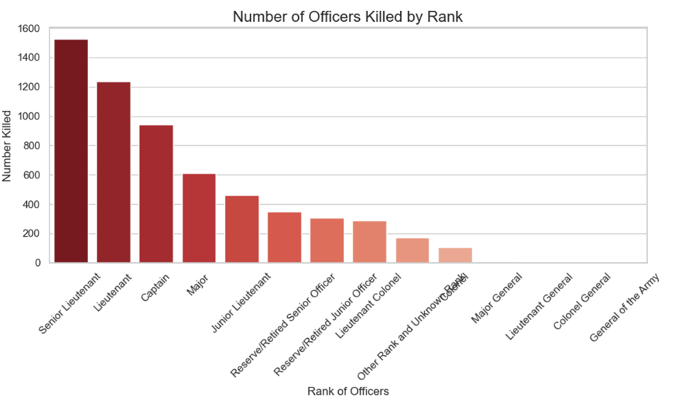

This indicates that **Lieutenants** being the top two suggests that **mid-level tactical leaders** are the most exposed. These ranks often lead **platoon- or company-sized units,** putting them directly in combat situations and thus at higher risk.

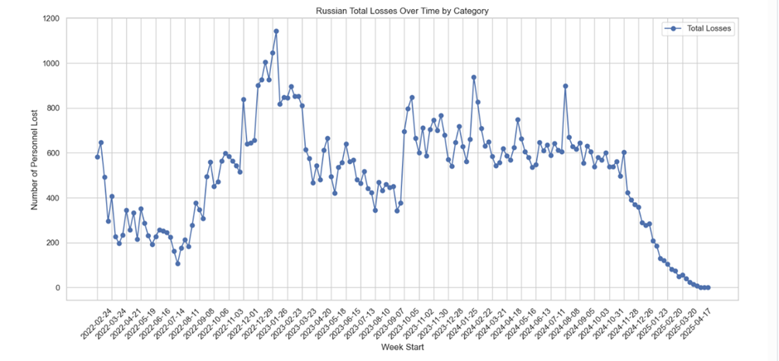

Key observations:

* Sharp spikes in the beginning of the war reflect intense combat during the early invasion phases. They could suggest unpreparedness or underestimation of Ukrainian resistance.
* Spikes during late 2022 may coincide with the 2022 Kherson counteroffensive in which Ukraine manages to recapture 1,170 square kilometers of land (Wikipedia, 2022).
* Decline in start of 2025 may indicate exhaust of resources, defeat in certain zones or ceasefires.

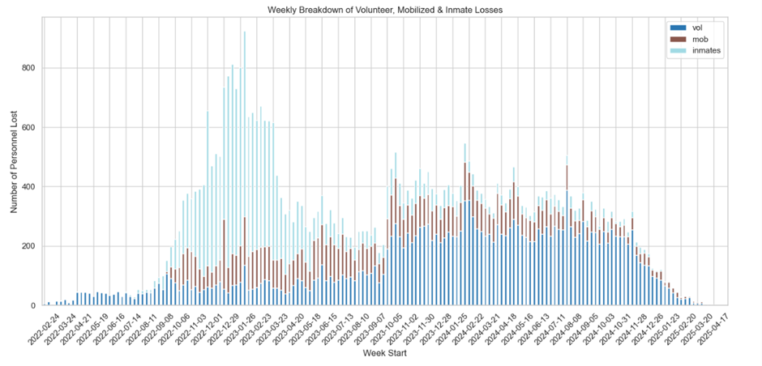

Inmate soldiers suffered significant losses during the war. The Foreign Intelligence of Ukraine has claimed that Russia has recruited between 140,000 and 180,000 convicts to fight Ukraine (The Kyiv Independent, 2025). This was done by the Wagner group which is a Russian state-funded private military company controlled by Yevgeny Prigozhin, a close ally of Putin who specifically said that these troops would be used as ‘shock troops’ – who lead attack and take heavy casualties.

## 

## 

## Equipment Losses

1. Trend Analysis through Visualizations

* Line plots of total equipment losses over time for Russia and Ukraine.

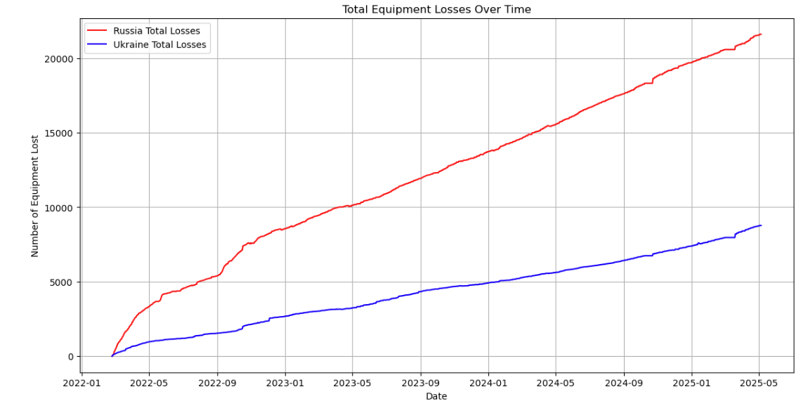

We can observe continuous, almost linear increase in the cumulative loss of equipment (tanks, aircrafts, artillery).

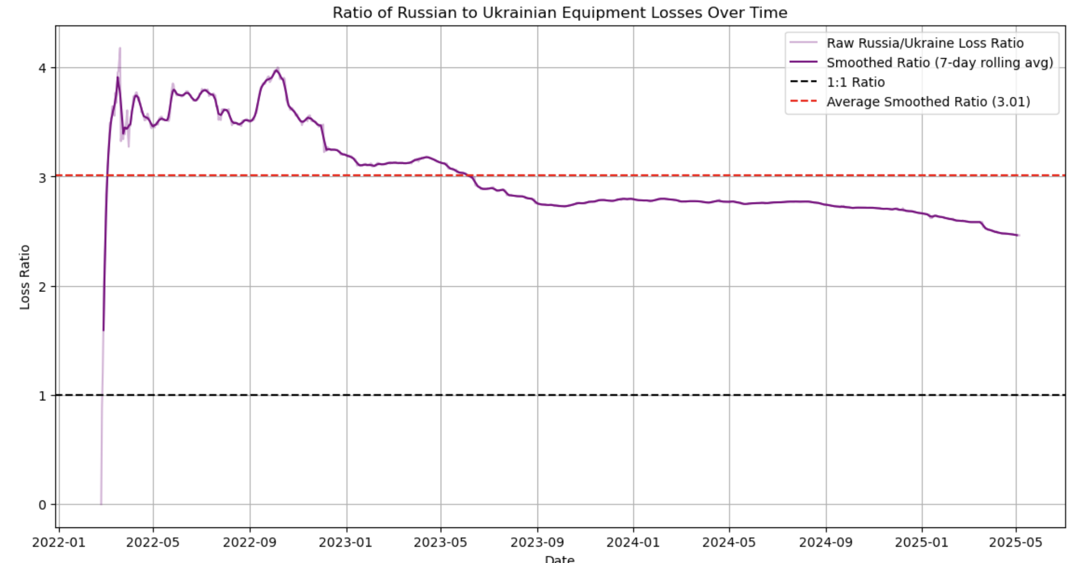

Values above 1 mean Russia lost more while those below 1 means Ukraine lost more. For the entire duration of the war, Russia lost more with an average of 3 Russian equipment losses for every 1 Ukrainian equipment loss.

* Category-wise equipment trends for Tanks, Aircraft, and Artillery.

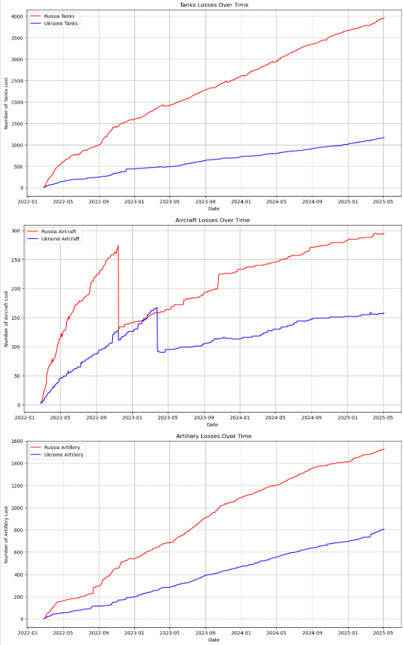

Here, we identified, unusual drops in aircraft data on 2023-03-27 and 2022-11-15. They are may be erroneous because cumulative data cannot suddenly drop. Therefore, we have assumed that the post-drop is the correct one since it has been recorded for the longer duration and have adjusted the pre-drop data by subtracting the last value before drop for both countries.

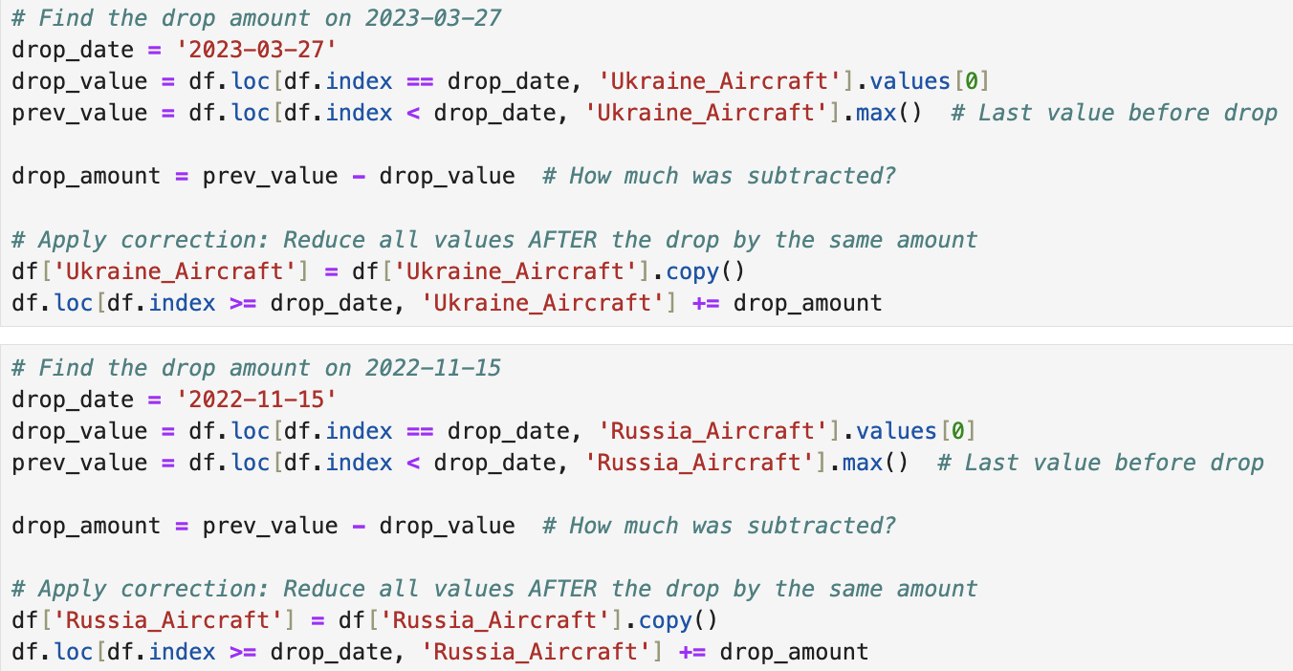

Aircraft data after corrections:

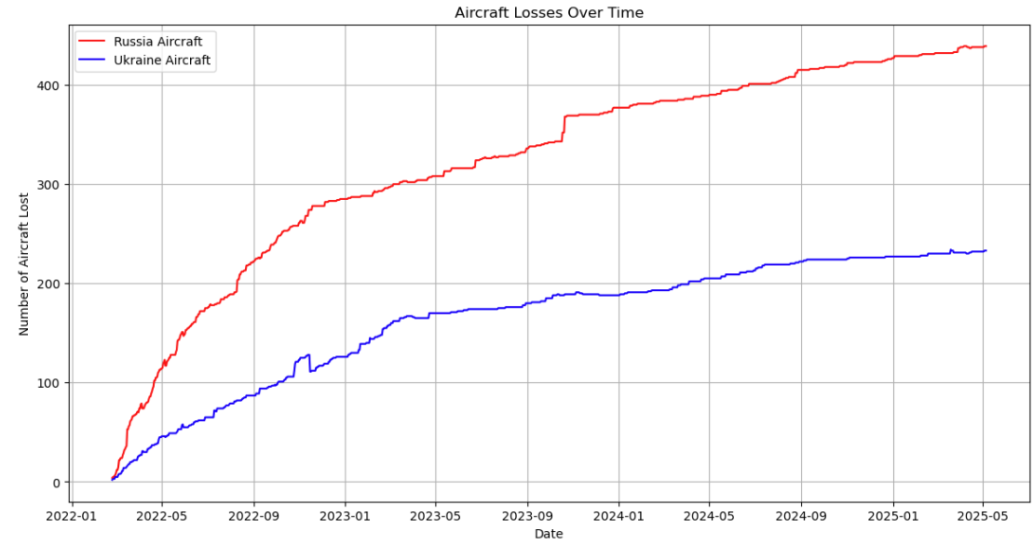

1. Correlation Analysis:

* Computed and visualized the correlation matrix using a heatmap for key metrics.

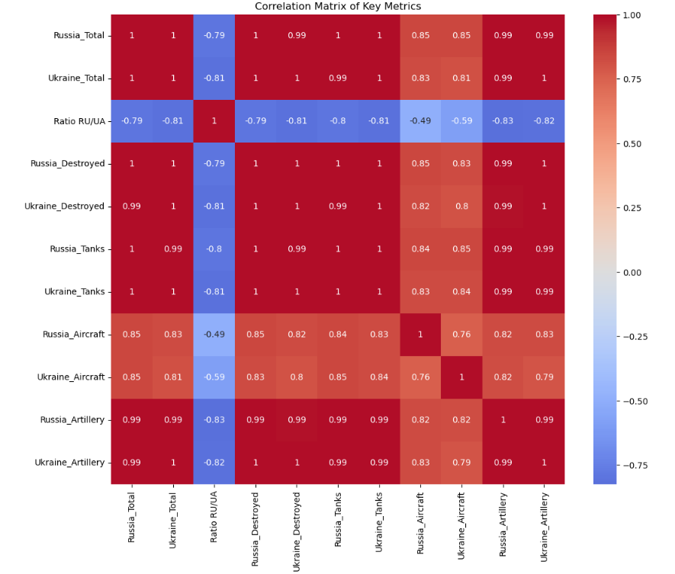

Correlation of 1 is suspicious because it indicates that both sides lost equipment proportionately. However, during further investigation, taking tank losses as the point of interest, it shows that while they differ in scale, their rise and fall match in pattern.

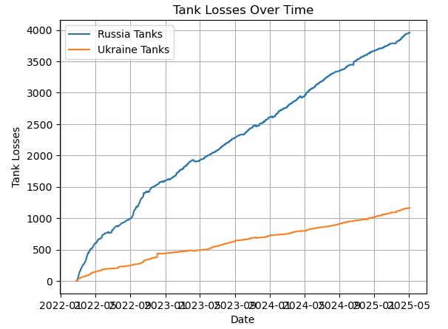

Furthermore, a linear scatter plot implies that each value of Ukraine_tanks corresponds to a scaled or shifted value of Russian_tanks hence the perfect correlation.

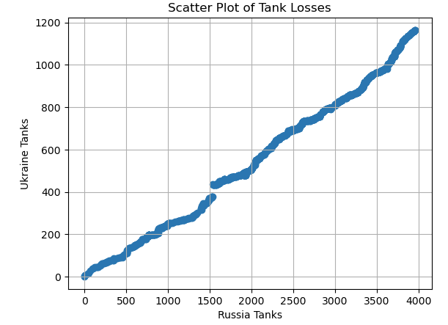

Analyzing the daily change in tank losses also revealed irregularities namely the negative tank losses which we assumed to be errors since negative tank losses indicate that the side has actually gained tanks instead of lose.

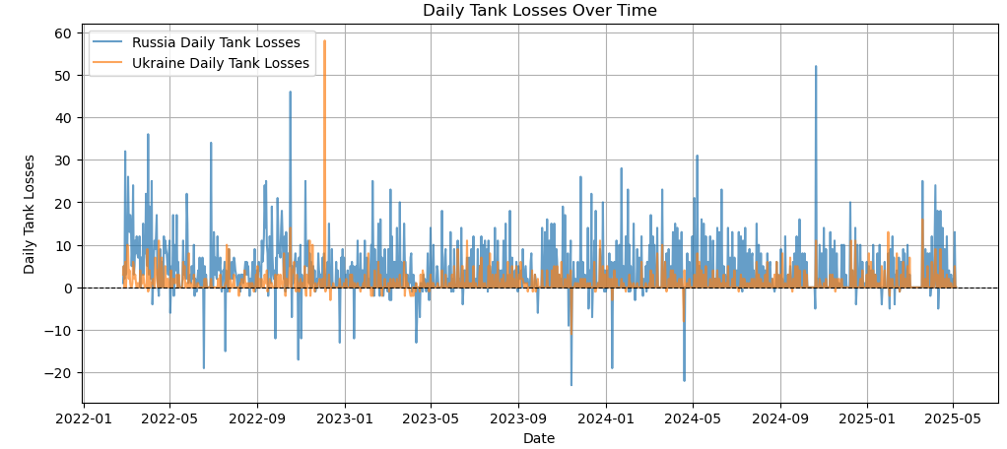

After removing or correcting negative values (which are likely noise or errors), the version below shows a cleaner signal where sharp spikes suggest specific impactful events or battles.

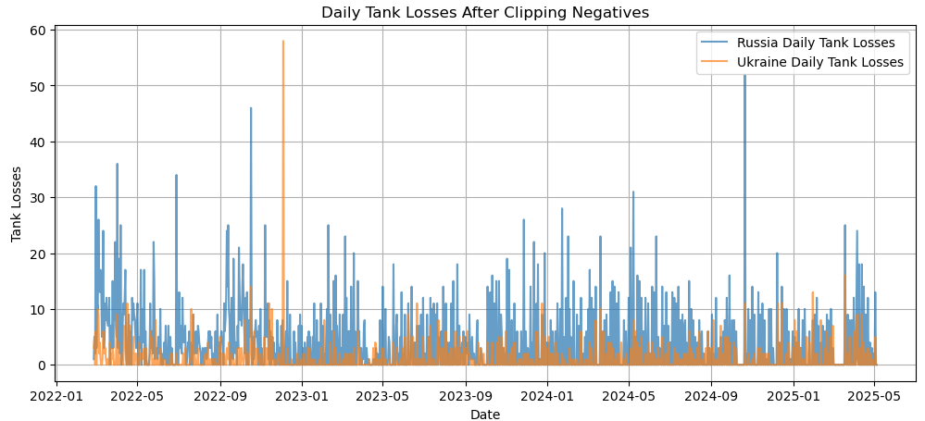

## Economic impacts

This section of the analysis is limited in the fact that we have not been able to acquire data for 2024 to 2025. Therefore, we have opted to study economic indicators from 2014 which is the start of the Russo-Ukrainian War which began with the Russian annexation of Crimea from Ukraine.

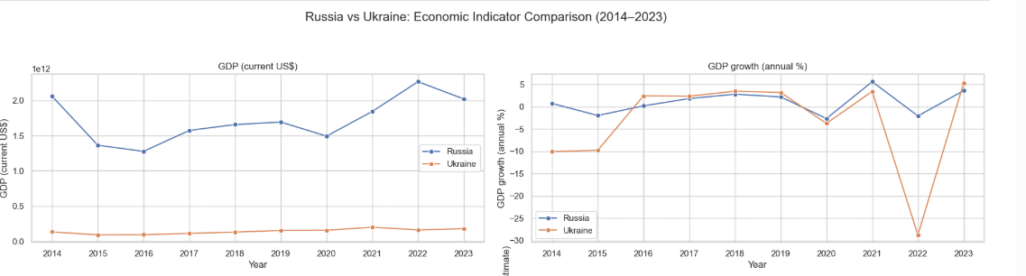

GDP current – the monetary value of all goods and services in the country.

Ukraine’s GDP has remained stable with a minor rise until 2021 while Russia’s has seen spikes possibly due to oil sanctions, Covid-19 and the war related economic pressure. GDP growth for Ukraine has seen deep collapse in 2022 due to the full-scale Russian invasion similar to Russia though less dramatic than Ukraine.

Russia GDP growth percentage decrease in 2022: 136.87%

Ukraine GDP growth percentage decrease in 2022: 934.64%

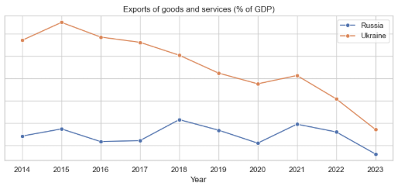

Export of goods and services show a gradual decrease for Russia with both experiencing decrease in 2022 due to the constraints of the war.

## Ukraine casualties

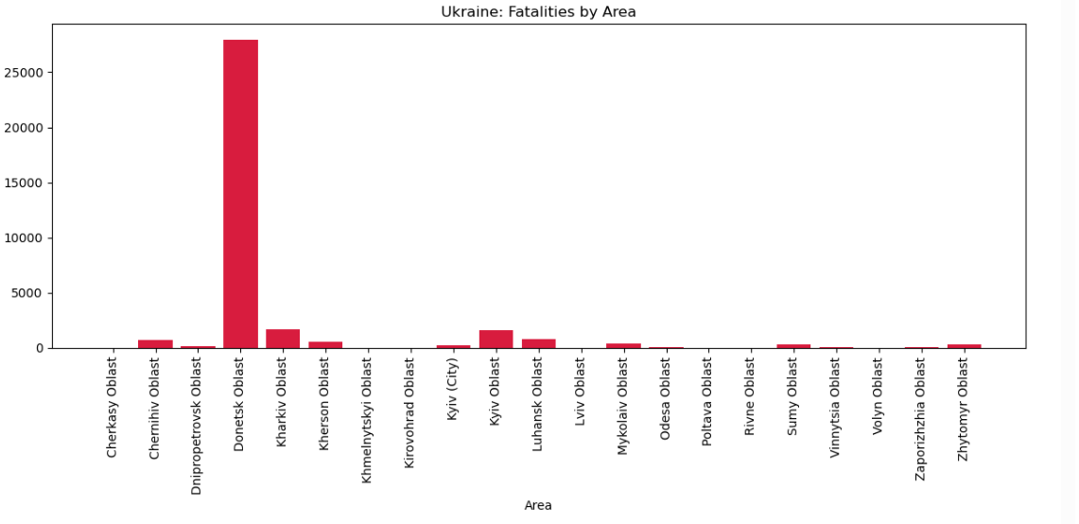

The Donetsk Oblast has over 25000 casualties primarily due to Mariupol, a port city close to the border with Russia which was pounded relentlessly from the air and from the ground (Andersson, 2022). Ukrainian officials believe that at least 25000 civilians died in the city with thousands dying under the rubble after the city was bombed.  
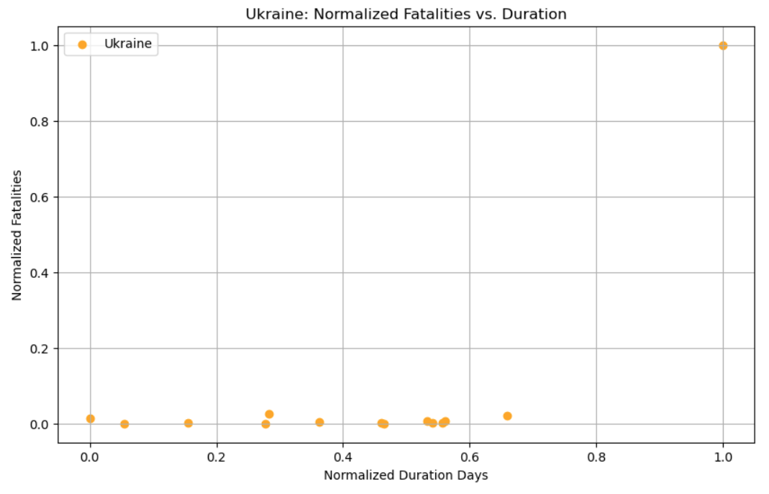

We observe here in the normalized fatalities vs duration that other than Donetsk oblast, all the other area fatalities are quite less.

# Statistical Analysis and Predictive Modeling

The bar charts below illustrate the distribution of different types of aid (Financial, Military, and Humanitarian) provided before 2023 and since 2023. Before 2023, Financial and military aid were both exceeding €60 billion. However, since 2023, there has been a notable increase in the total volume of aid across all categories. Financial aid saw the most significant rise, surpassing €140 billion, making it the predominant form of assistance. Military aid also increased substantially, exceeding €100 billion. This shift suggests a scaling up of international support efforts for Ukraine potentially reflecting escalating global conflicts or strategic financial support initiatives.

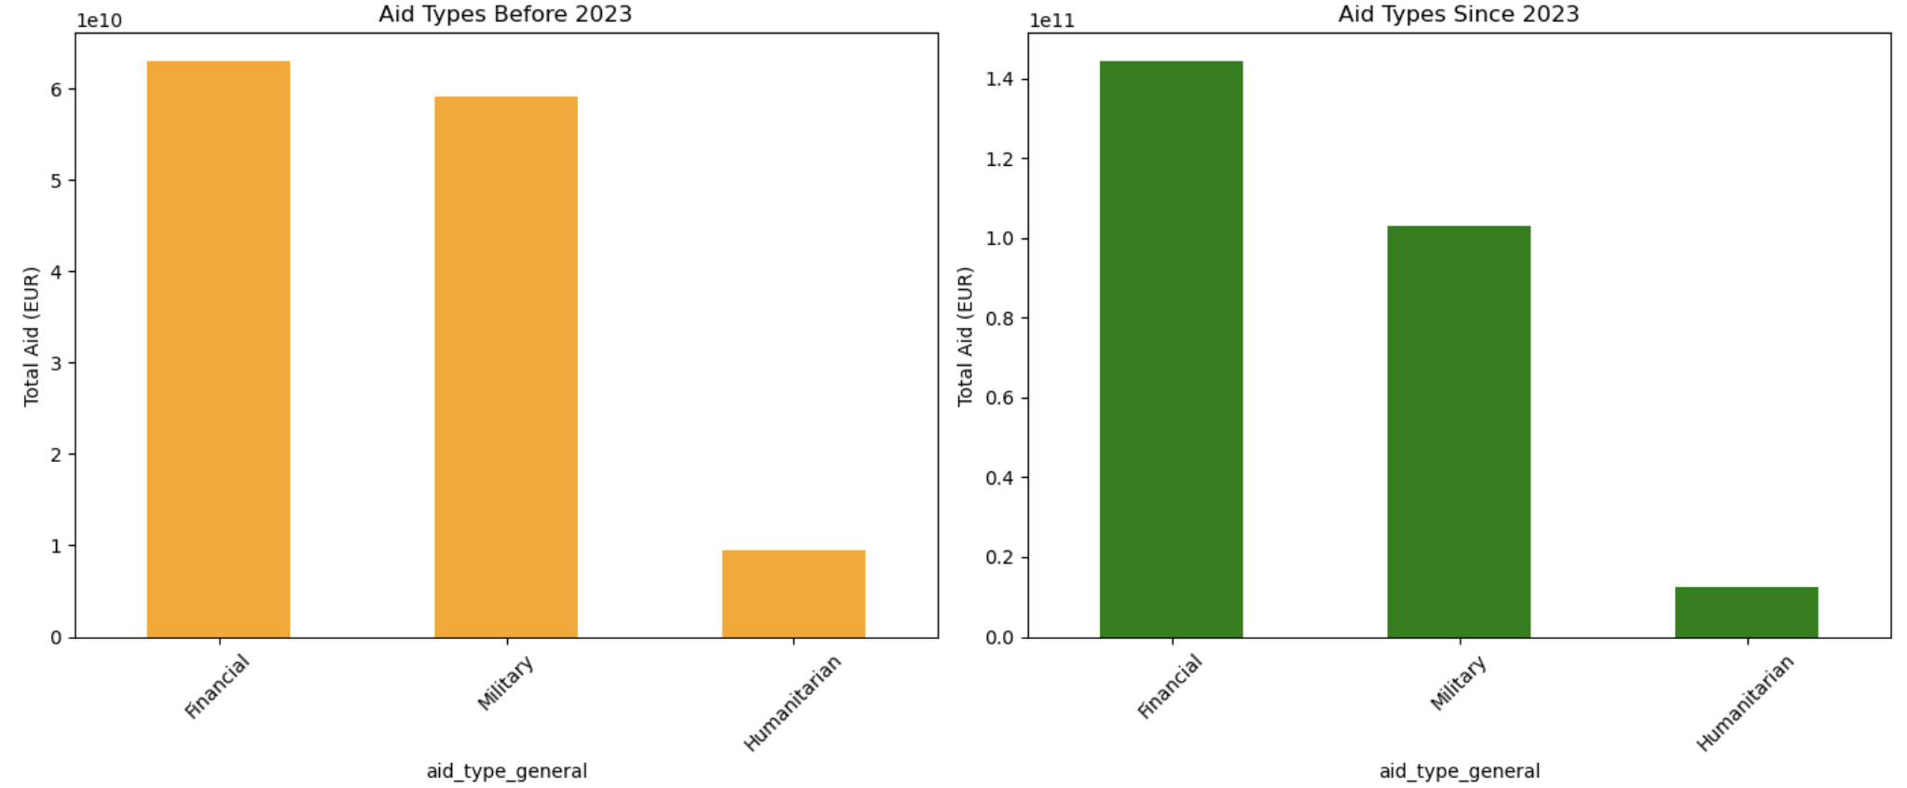

Furthermore, we observe that over the course of three years with a total aid of over 390,000,000,000 billion euros, aid has been largely financial (52.9%) and military (41.5) with less emphasis on humanitarian aid.

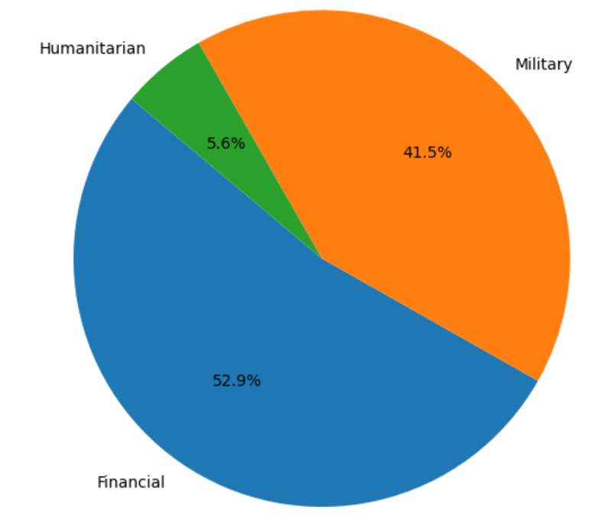

|  |  |
| --- | --- |
| **Year** | **Total aid (EURO)** |
| **2022** | 131585572366.0 |
| **2023** | 119103581905.0 |
| **2024** | 140766577738.0 |

We can further evaluate whether the rate of equipment losses differ for the countries. This is useful to find out which side is experiencing relatively greater loss since at face-value, Russia has a significally higher total equipment loss.

The daily equipment losses for both countries were summed and averaged.

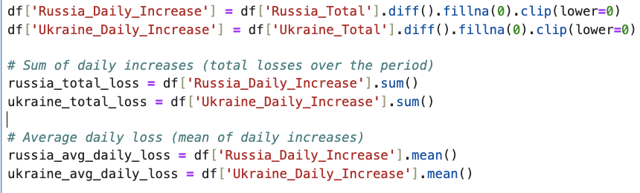

Russia total loss: 22202.0

Ukraine total loss: 9035.0

Russia average daily loss: 19.06

Ukraine average daily loss: 7.76

Over the analyzed period, Russia incurred a significantly higher volume of equipment losses compared to Ukraine. With a total of 22,202 units lost and an average daily loss rate of 19.06, Russia's equipment attrition far outpaced Ukraine’s, which recorded 9,035 total losses at an average of 7.76 per day. This disparity highlights the intensity and scale of Russian material depletion, with total losses exceeding Ukraine’s by more than 2.4 times. The sustained higher rate of Russian losses may reflect both the scale of its deployed forces and the impact of Ukrainian resistance over time.

The correlation of total equipment losses with the number of days passed are as follows:

Correlation of Russia_Total with date: 0.9960

Correlation of Ukraine_Total with date: 0.9979

This indicates high correlation. Therefore we can use linear regression to predict the total equipment losses over the next time period. While linear regression was chosen initially due to high correlation, correlation only measures linear association, not predictive robustness. To validate this and ensure modeling reliability, more complex models were tested.

List of models tested:

* Linear regression
* Random forest regression
* ARIMA (Autoregressive Integrated Moving Average)

Results:

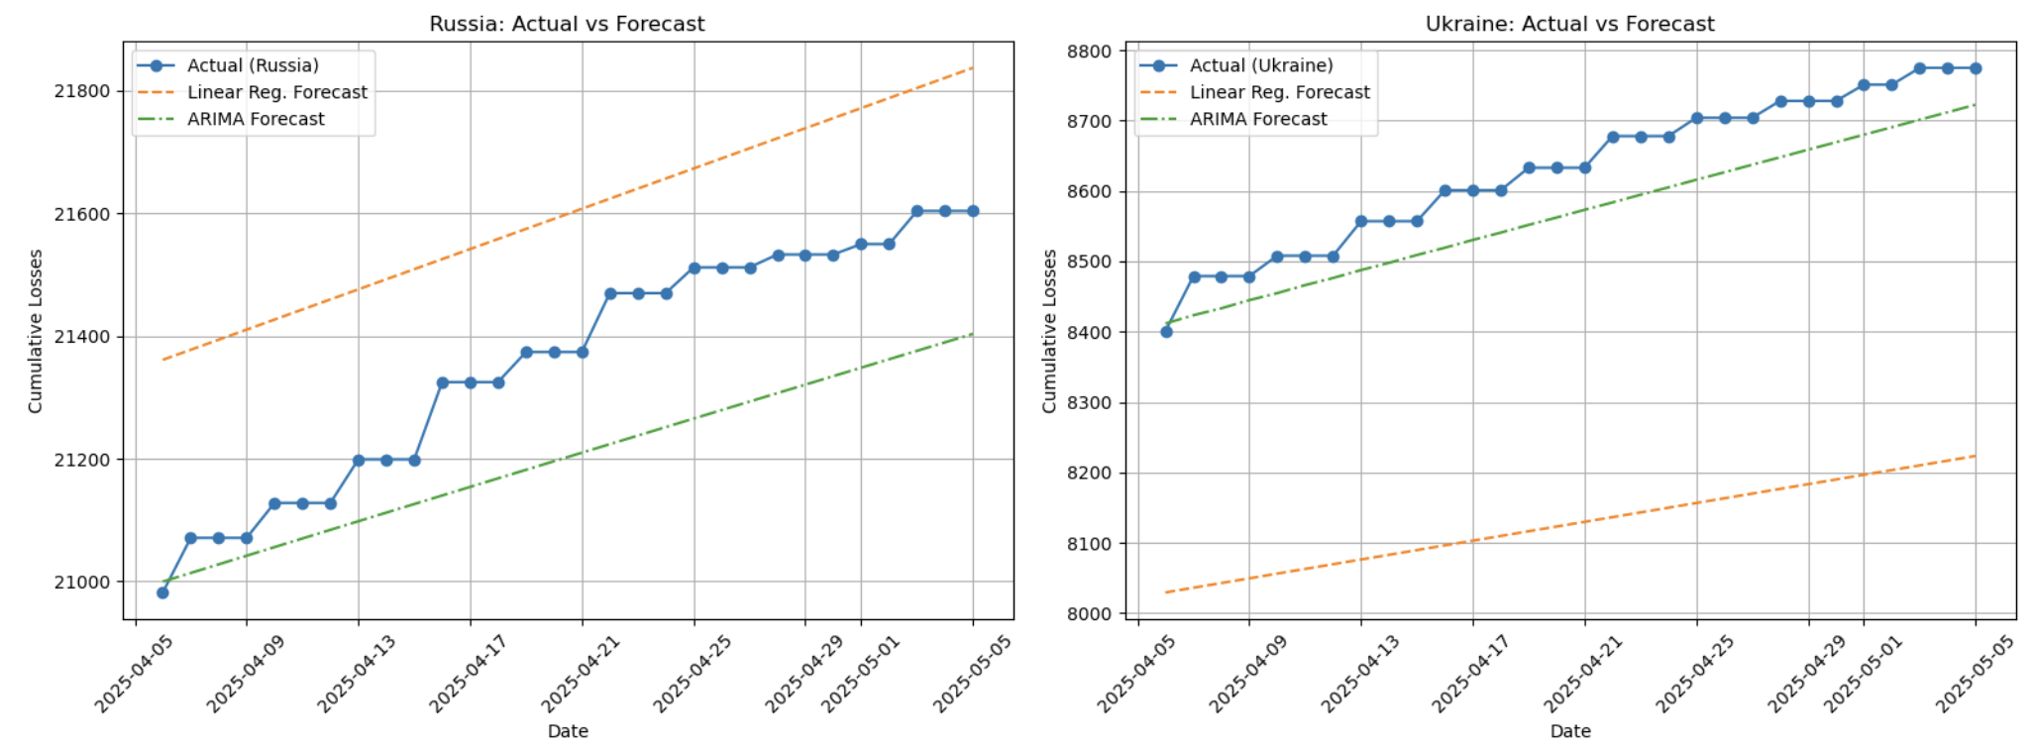

Comparison of ARIMA and linear regression for equipment loss forecast

|  |  |  |  |  |  |  |
| --- | --- | --- | --- | --- | --- | --- |
| **Model** | **RMSE (Russia)** | **MAE (Russia)** | **R² (Russia)** | **RMSE (Ukraine)** | **MAE (Ukraine)** | **R² (Ukraine)** |
| **Linear Regression** | 248.8 | 241.64 | -0.71 | 505.67 | 503.33 | -22.35 |
| **Random Forest** | 421.95 | 376.75 | -3.93 | 251.81 | 229.03 | -4.79 |
| **ARIMA** | 173.02 | 156.42 | 0.17 | 65.35 | 62.87 | 0.61 |

Model evaluation table

It is evident that ARIMA significantly outperforms linear and random forest regression in all three metrics: root mean squared erro, mean absolute error and R2 score. Using ARIMA, we then made the forecast for the total equipment loss for the next six-months after the last entry of the dataset.

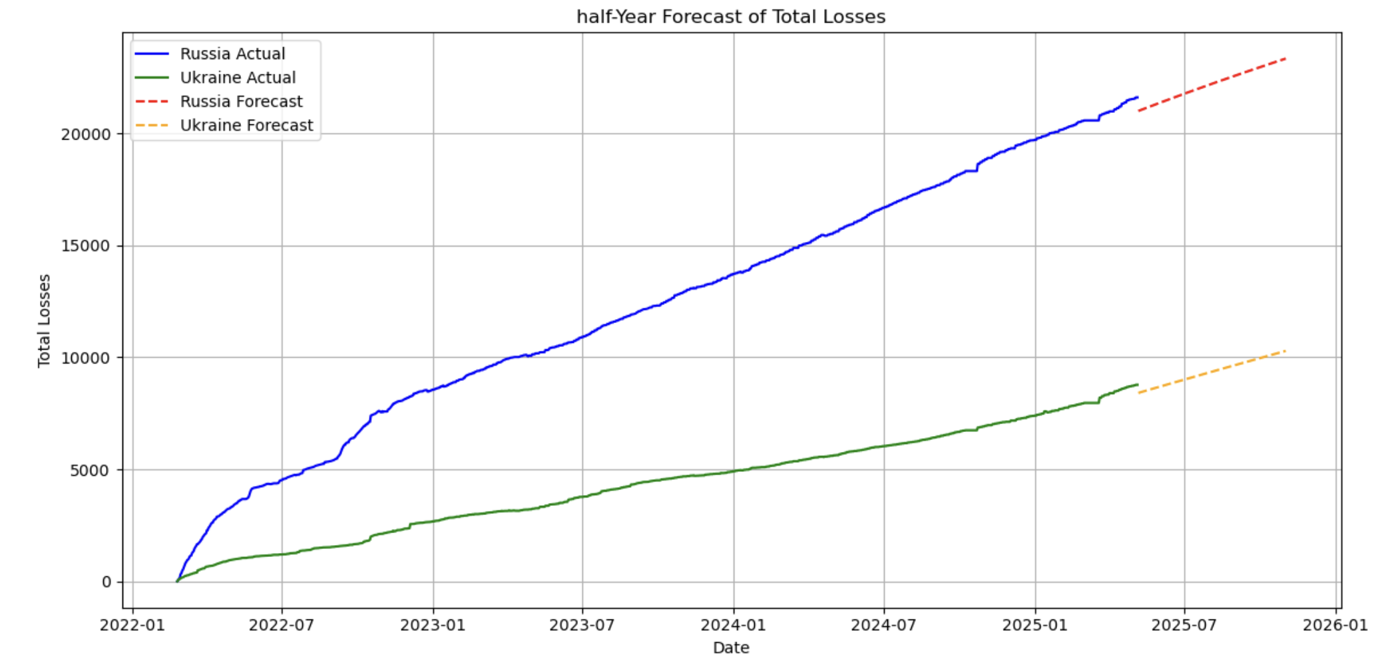

Forecasted additional Russia losses (next half year): 1733

Forecasted additional Ukraine losses (next half year): 1512

As of May 2025, the total recorded equipment losses stand at 21,604 for Russia and 8,775 for Ukraine. Based on the forecast models, the projected additional equipment losses over the next six months are approximately 1,733 for Russia and 1,512 for Ukraine.

Despite the historical difference in total losses, the forecast suggests that both countries are expected to incur a similar number of equipment losses in the upcoming half-year period, indicating a potential convergence in the rate of attrition.

# Data Visualization Dashboard

User - interactive dashboard was made using Dash, a Python framework for building simple dashboards. This framework does not need any advanced web development skills. It integrates seamlessly with technologies like Flask, React. js, and Plotly.

The dashboard is divided into seven sections or tabs:

1. Economic indicators
2. Financial aid to Ukraine
3. Russian losses
4. Equipment losses
5. Loss forecasting
6. Civilian losses
7. Ukraine civilian losses

1. Economic indicators

This tab shows different economic indicators throughout the course of the war for both countries.

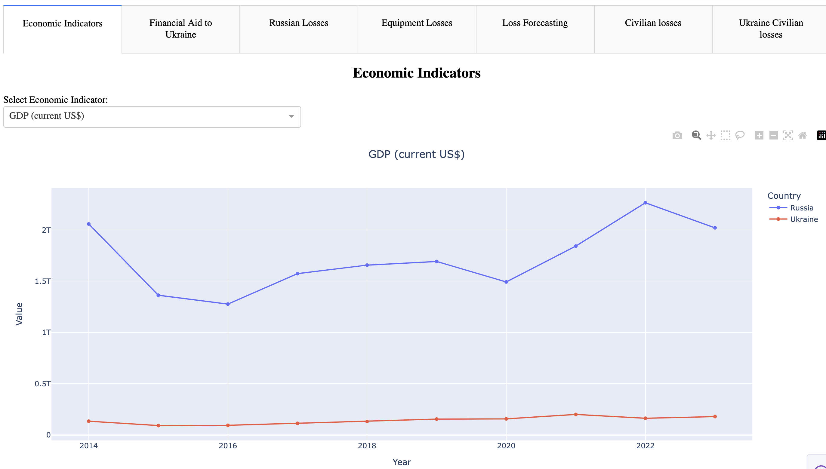

2. Financial aid to Ukraine

This tab shows the types and sources of aids Ukraine has received throughout the war. It also shows the countries who provided the most and least amount of financial aid.

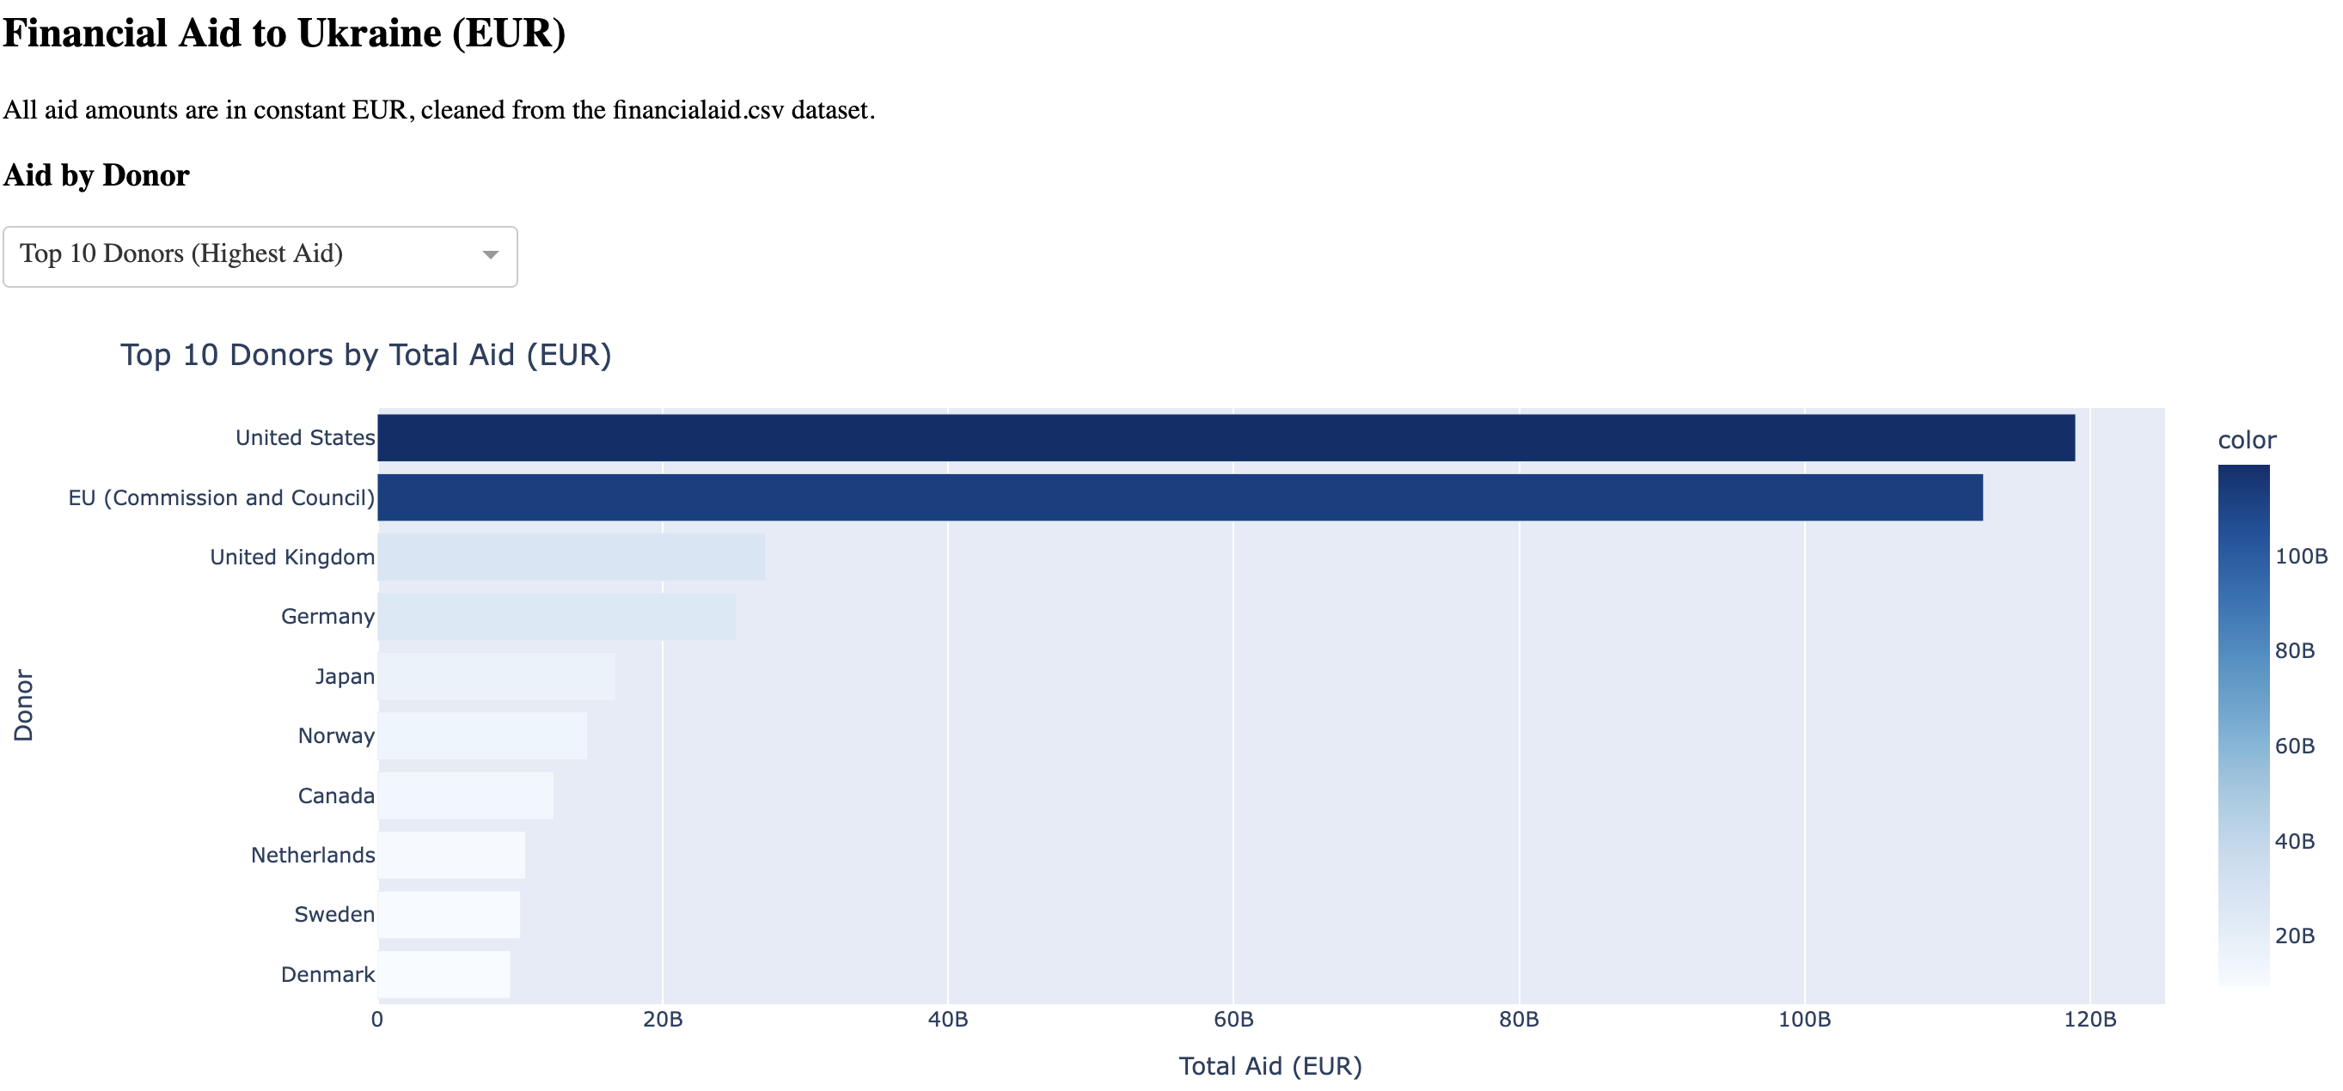

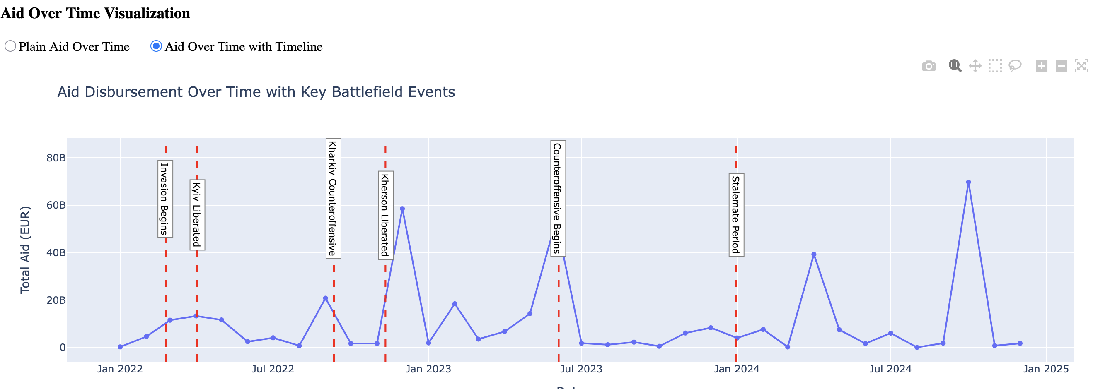

3. Russian losses

This tab shows the Russian personnel losses overtime including categorized based on the type of troop as well as by officer rank.

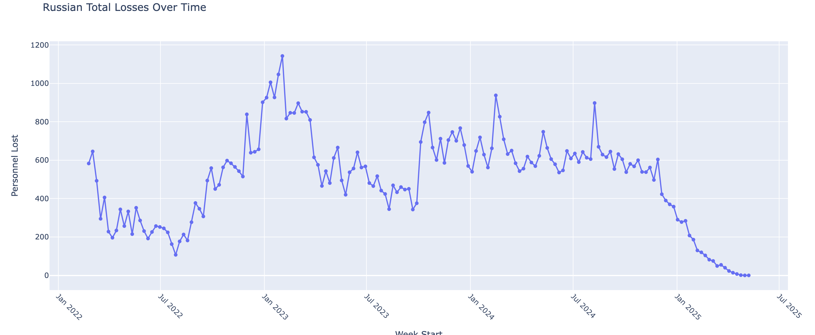

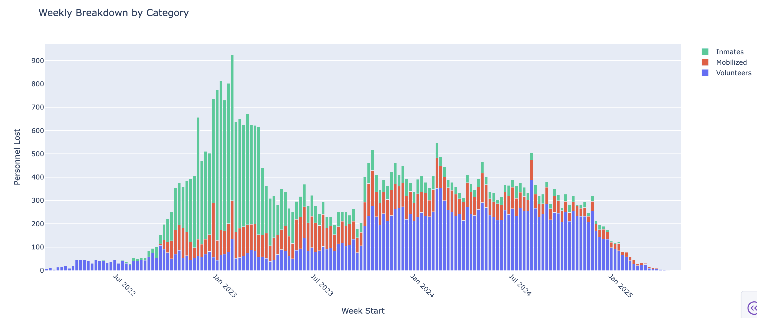

4. Equipment losses

This tab shows the comparison of equipment (tanks, aircrafts, artillery) for both countries with a user adjustable timeline.

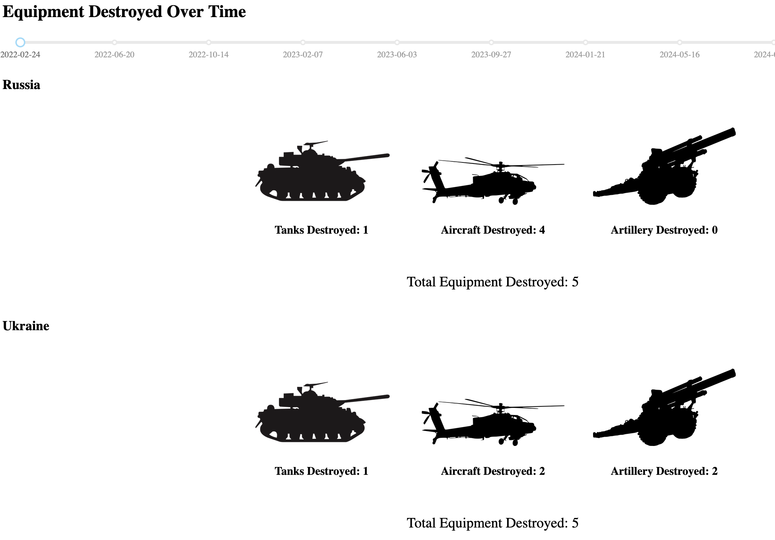

5. Loss forecasting

This tab shows the total equipment loss forecast for the next six months for both countries.

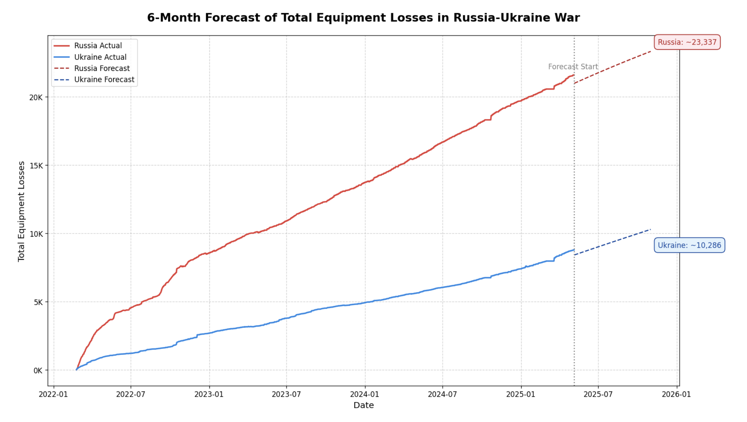

6. Civilian losses

This tab shows the civilian fatalities in different areas for both countries along with a per day fatality rate for Ukraine.

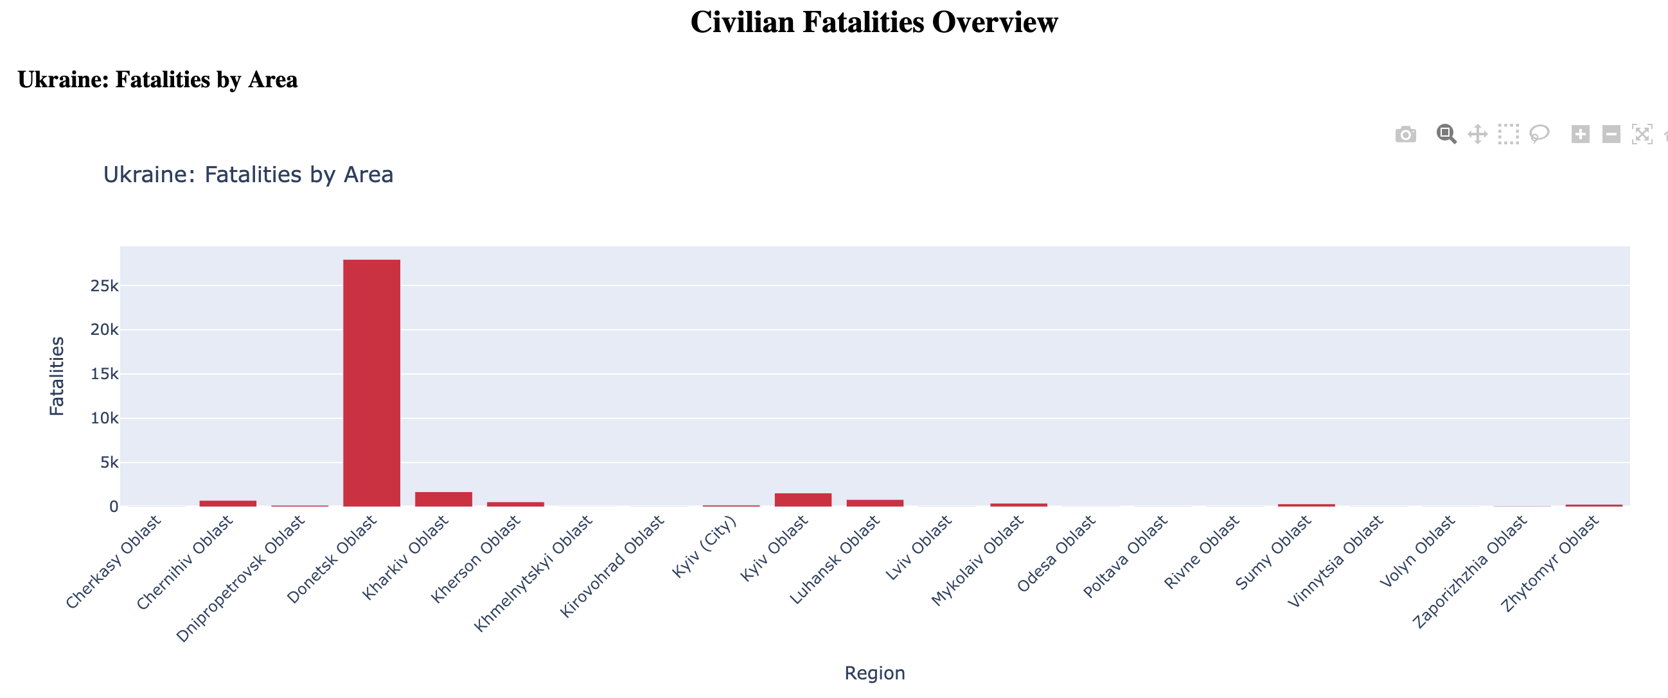

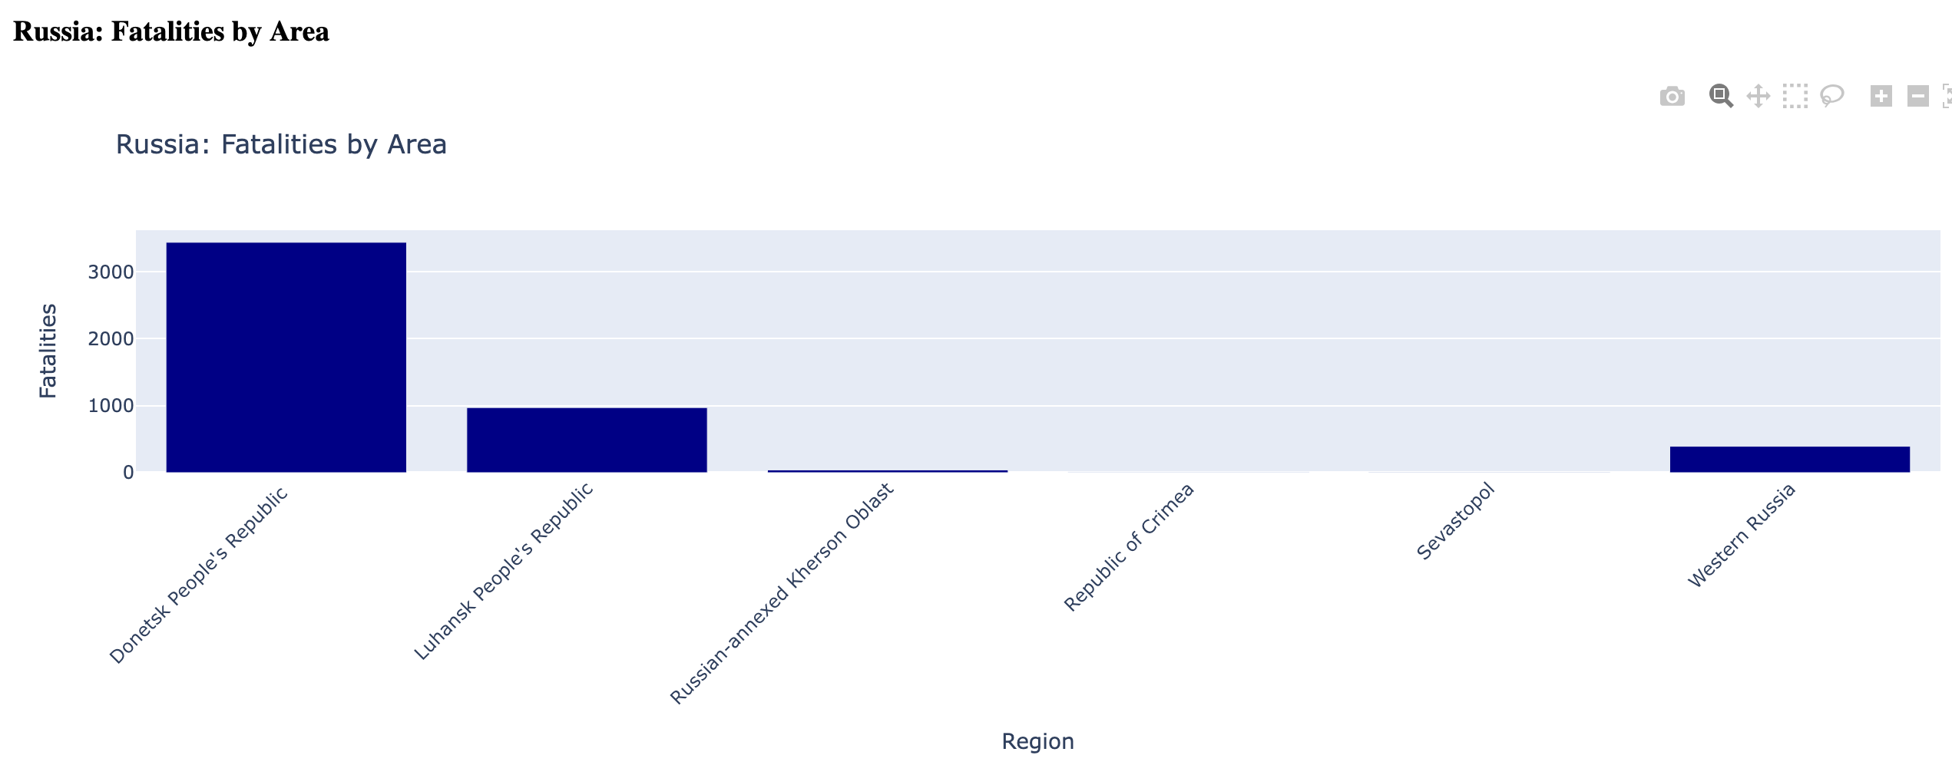

7. Ukraine civilian losses

This tab shows the Ukraine civilian losses for the different provinces in Ukraine.

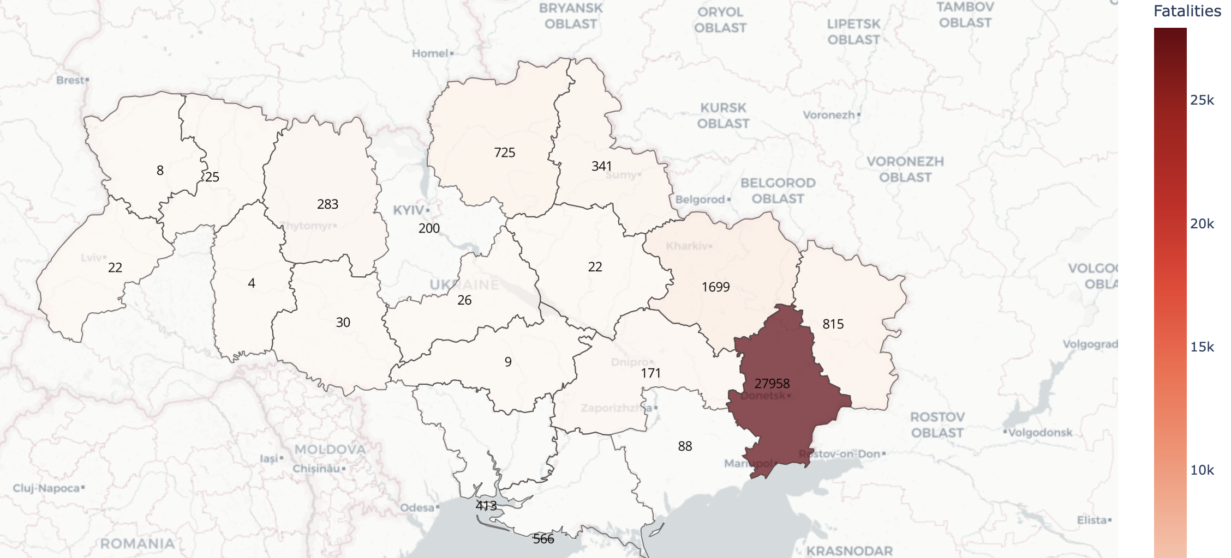

# Conclusion

This mini-project focused on the Russo-Ukrainian War and its multifaceted impact on both Russia and Ukraine, analyzing three critical dimensions: human casualties, equipment losses, and economic indicators. The analysis revealed several notable trends, including a steady rise in casualties on both sides, disproportionately higher equipment losses for Russia, and a continuous decline in GDP for both nations in recent years. These findings suggest that although both countries have endured substantial losses since the onset of the war in 2014 and more notably following Russia’s full-scale invasion of Ukraine in 2022, Russia has suffered relatively greater overall losses in terms of both military equipment and economic deterioration.

# Limitations and further work

While this mini-project provided valuable insights into the human, equipment, and economic costs of the Russo-Ukrainian War, several limitations must be acknowledged. First, the analysis was constrained by the availability of data in the required timeframe. Also, official figures may be underreported or biased, especially in conflict zones. Additionally, the scope was focused mainly on descriptive and exploratory analysis, leaving limited effort for predictive modeling. The visualization tools, although informative, were relatively static and did not include real-time updates.

For future work, the project could be expanded to include more dynamic and predictive elements. Integrating live data feeds and incorporating machine learning techniques could enable forecasting of casualty trends or economic impact. Furthermore, including geospatial data could provide a more granular understanding of conflict dynamics. Finally, enriching the analysis with qualitative data such as policy responses or media sentiment would offer a more comprehensive view of the war’s broader implications.

# References

Andersson, B. H. (2022). The agony of not knowing, as Mariupol mass burial sites grow. BBC News. Retrieved from <https://www.bbc.com/news/world-europe-63536564>

GeeksforGeeks. (2024). Model Selection for ARIMA. GeeksforGeeks. Retrieved from https://www.geeksforgeeks.org/model-selection-for-arima

Mediazona. (2025, April 25). Russian losses in the war with Ukraine. Mediazona count, updated. *Mediazona*. <https://en.zona.media/article/2025/04/25/casualties_eng-trl>

NathOrmond. (n.d.). *GitHub - NathOrmond/ukraine-war-data*. GitHub. <https://github.com/NathOrmond/ukraine-war-data.git>

The Kyiv Independent. (2025, January 15). Retrieved from <https://kyivindependent.com/russia-recruits-up-to-180-000-convicts-for-war-against-ukraine-foreign-intelligence-service-says>

Trebesch, C., Bomprezzi, P., Nishikawa, T., & Kharitonov, I. (2025, April 6). *Ukraine support tracker data*. Kiel Institute. <https://www.ifw-kiel.de/publications/ukraine-support-tracker-data-20758/>

Wikipedia contributors. (2025, May 20). *Casualties of the Russo-Ukrainian War - Wikipedia*. <https://en.wikipedia.org/wiki/Casualties_of_the_Russo-Ukrainian_War#Total_casualties>

*World Bank Open Data*. (n.d.). World Bank Open Data. <https://data.worldbank.org/country/ukraine>

2022 Kherson counteroffensive. (2025, May 05). Wikipedia. <https://en.wikipedia.org/w/index.php?title=2022_Kherson_counteroffensive&oldid=1289005560>

# Appendix

**Dashboard**

The interactive dashboard and all relevant datasets are available on GitHub:  
[**https://github.com/karmat314/Data-analytics-project.git**](https://github.com/karmat314/Data-analytics-project.git)

To run the dashboard locally, follow these steps:

1. Set up a virtual environment (optional but recommended).
2. Install the required Python libraries using pip or pip3:
   * dash
   * geopandas
   * plotly
   * matplotlib
3. Navigate to the ‘Dashboard’ directory within the repository.
4. Run the dashboard application:

python app.py or python3 app.py

1. Open a web browser and go to:  
   [**http://127.0.0.1:8050/**](http://127.0.0.1:8050/)  
   to view the dashboard interface.